https://www.jxsggzy.cn/jyxx/002002/002002002/20200909/b52e2a58-aaa6-4591-85a7-1c4f90303d8b.html
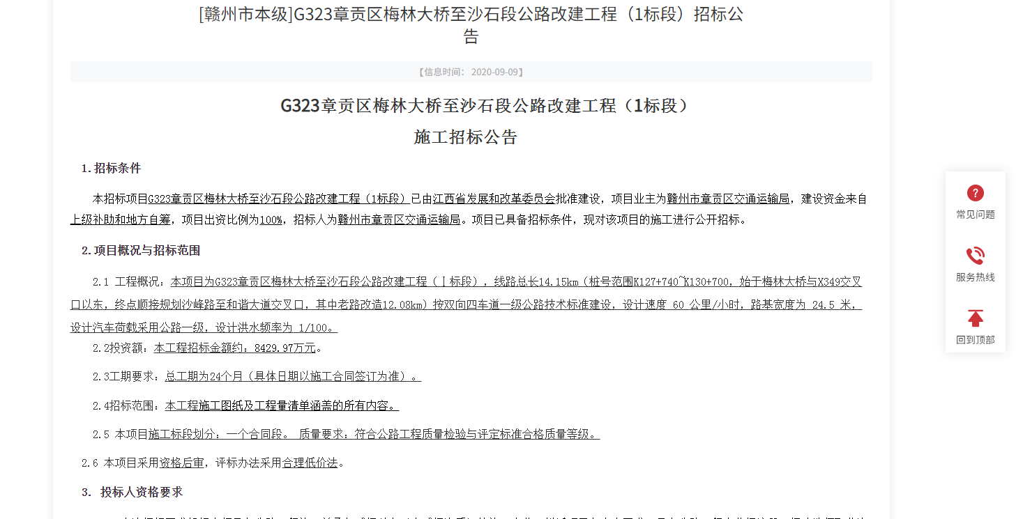

https://www.jxsggzy.cn/jyxx/002002/002002002/20210714/327f56c6-21ee-4655-ad3a-57b802d01077.html
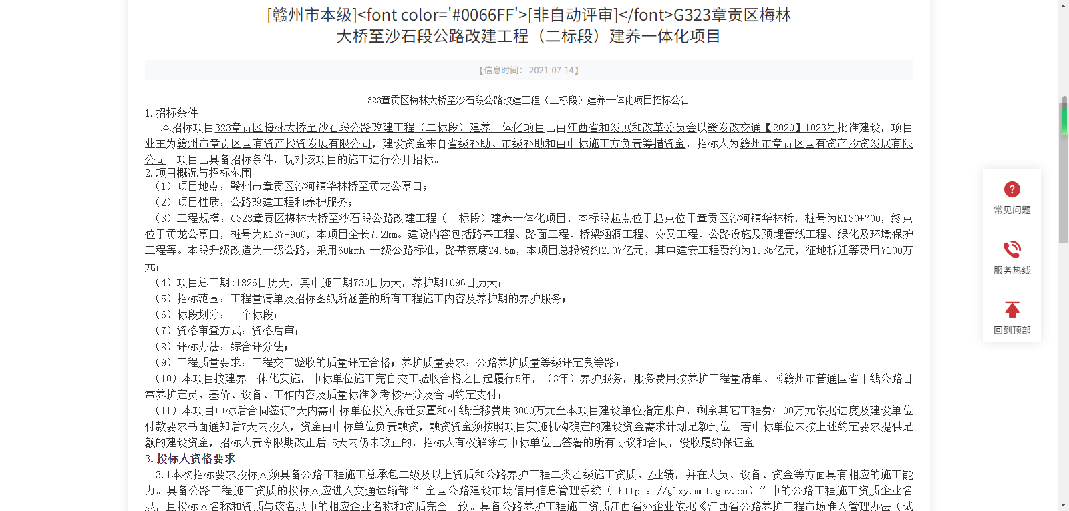

https://www.jxsggzy.cn/jyxx/002002/002002002/20200929/8d1ccb33-6a4a-498f-b6d1-778f914431ea.html
